Problem Statement
In this project, we are presented with a highly class-imbalanced data set with missing values typical of emerging market financial data. We are asked to predict whether a borrower will default on a loan using an ensemble framework model.
Dataset Description
The dataset was taken from Kaggle's Home Credit Group, a featured prediction competition. The primary datasets, application_train and application_test, contain demographic, financial, and loan applicant information for each borrower, identified by SK_ID_CURR. The training set contains 307,511 applications and 122 features, with a binary TARGET variable indicating default (1) or non-default (0). The target is highly imbalanced, with only 8.1% defaults (24,825) and 91.9% non-defaults (282,686). The six supplemental datasets capture prior credit activity from external bureaus and Home Credit's own historical records, linked to the primary data via SK_ID_CURR. As multiple records can correspond to a single loan application, each supplemental table was aggregated using summary statistics (mean, max, min, sum) and left-merged into the main dataset, resulting in one observation per application. We cleaned the data by handling missing values, duplicates, and outliers across all datasets. Missing values were treated carefully using "unknown", median, or zero imputation, and missingness flags. Finally, additional feature engineering was performed by creating financial behavior indicators and risk related ratios (such as debt-to-credit ratio), composite scores (Financial Stress Score and a Stability Score), cross-table features, and more.
Methodology
Following the project specification, a stacking ensemble approach was adopted. The key challenges of this dataset are severe class imbalance and high dimensionality. Four models were selected as base learners: XGBoost, LightGBM, Random Forest, and Logistic Regression. The first three are tree-based models that can all handle datasets with many features and missing values, but differ in their learning strategy. XGBoost and LightGBM use gradient boosting while Random Forest uses bagging. This promotes diversity in prediction errors, improving stacking performance. While the first three capture complex non-linear relationships, Logistic Regression focuses on linear patterns in the data, further diversifying the ensemble. The MLP meta-learner was chosen for its ability to learn non-linear combinations of the base model outputs.
Experimental Details
Architecture Description
The meta-learner is a shallow Multi-Layer Perceptron with two hidden layers. It receives as input the predicted probabilities from the four base learners (XGBoost, LightGBM, Random Forest, and Logistic Regression), resulting in a four-feature input layer. The first hidden layer has 32 neurons and the second has 16, both using ReLU activation. The output layer has a single neuron with Sigmoid activation, producing a probability of default.
Evaluation Metrics
The MLP meta-learner optimizes binary cross-entropy (log loss) during training. Due to the severe class imbalance, accuracy cannot be used as the key metric to evaluate model performance. Instead, ROC-AUC was used to evaluate and compare base learner performance, as it measures the model's ability to rank defaulters above non-defaulters across all possible thresholds. In this context, recall measures the proportion of actual defaulters that the model correctly identifies, while precision measures the proportion of predicted defaulters that are truly defaulters. Recall is prioritized over precision because failing to identify a defaulter results in a bad loan being approved, which is a costlier mistake than incorrectly flagging a non-defaulter. Once the meta-learner was trained, the classification threshold was tuned by searching the precision-recall curve for the value that maximized the F2 score, which weights recall twice as heavily as precision.
Dataset Split
The labeled dataset of 307,507 records was split into 80% for training (246,006 records) and 20% for final holdout testing (61,501 records). The 80% training set was used to train the base learners via 5-fold Stratified Cross-Validation, where each fold used 196,804 records (64% of total) for training and 49,202 records (16% of total) for validation, with stratification ensuring the minority class ratio was preserved across all folds. The OOF predictions generated during this process were used to train the MLP meta-learner, which reserved a further 10% (24,600 records) of the meta-training data as a validation set for early stopping. The 20% holdout was kept entirely unseen until final evaluation.
Implementation Details
For the base learners, XGBoost was configured with 100 estimators, learning rate of 0.1, max depth of 5, and L2 regularization (reg_alpha=0.1, reg_lambda=2), with scale_pos_weight=11.4 to account for class imbalance. LightGBM used 1000 estimators, learning rate of 0.05, max depth of 5, min_child_samples=100, and is_unbalance=True. Random Forest used 100 estimators, max depth of 10, balanced class weights, and sqrt feature sampling per split. Logistic Regression was wrapped in sklearn's CalibratedClassifierCV (sigmoid method, cv=3) to produce well-calibrated probabilities. The Logistic Regression base learner also used L2 regularization with C=0.1, the liblinear solver, balanced class weights, and a maximum of 500 iterations. The MLP meta-learner used the Adam optimizer with a learning rate of 0.001, two hidden layers (32, 16) with ReLU activation, L2 regularization (alpha=0.001), and early stopping with a patience of 10 iterations using 10% of the meta-training data as validation.
Other Methods
Several additional techniques were used to enhance model performance. SMOTE (Synthetic Minority Over-sampling Technique) was applied to the meta-training data only to balance the class distribution before fitting the MLP. The holdout set remained untouched. Within the Logistic Regression pipeline, quadratic polynomial features were generated on selected columns, allowing the linear model to capture non-linear interactions. As the dataset is highly imbalanced, and missing a positive case is more costly than generating a false positive, the classification threshold was optimized using the F2 score rather than F1. F2 places greater emphasis on recall, helping the model identify a larger proportion of true defaulters.
Results
The holdout results are summarized in Table 1 below. Among the base learners, LightGBM performed best with a ROC-AUC of 0.7901, followed by XGBoost (0.7844), Logistic Regression (0.7798), and Random Forest (0.7631). The MLP meta-learner achieved a ROC-AUC of 0.7930, meaning that in 79.3% of cases the model correctly ranks a defaulter above a non-defaulter. The meta learner outperformed all individual base learners for this metric. The MLP also achieved the highest recall of 0.7046, meaning it correctly identified nearly 71% of actual defaulters, which is the most critical objective in this problem. The Logistic Regression (LR), despite its high accuracy of 0.9195, had a recall of only 0.0255 and an F2 of 0.0315. These results show how accuracy is misleading under class imbalance and as the LR model essentially predicted non-default for nearly every applicant.
Table 1: Model Performance on Holdout Test Set
Learner | Accuracy | Precision | Recall | F1 Score | F2 Score | ROC-AUC
XGBoost | 0.7349 | 0.1872 | 0.6864 | 0.2942 | 0.4476 | 0.7844
Random Forest | 0.7591 | 0.1890 | 0.6056 | 0.2880 | 0.4203 | 0.7631
LightGBM | 0.7658 | 0.2027 | 0.6513 | 0.3092 | 0.4515 | 0.7901
Logistic Regression | 0.9195 | 0.4975 | 0.0255 | 0.0485 | 0.0315 | 0.7798
MLP Meta-Learner | 0.7316 | 0.1906 | 0.7046 | 0.3000 | 0.4577 | 0.7930

Visualizations
Figure 1 Figure 2
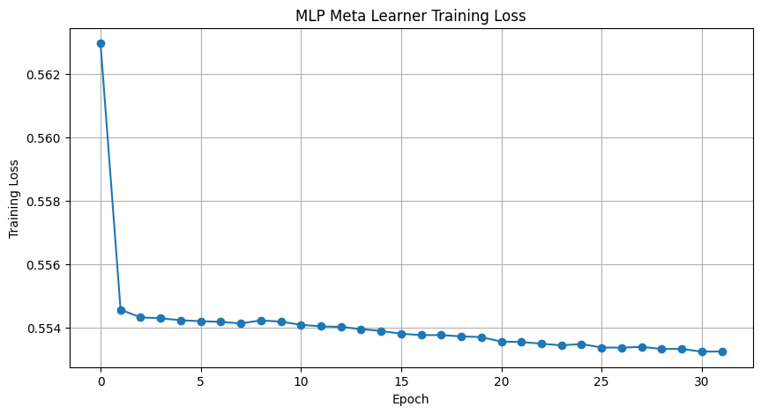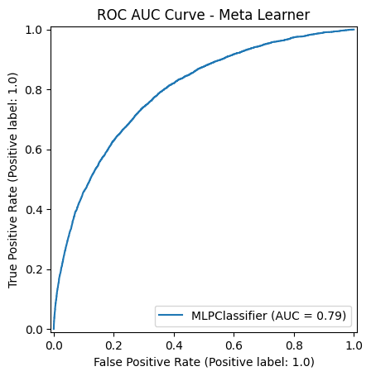
Figure 1 shows the MLP meta-learner training loss decreasing steadily over 31 epochs, indicating stable convergence, alongside the Figure 2 of ROC-AUC curve confirming an AUC of 0.79 on the holdout set.

Analysis & Improvements

The ensemble approach yielded strong recall, with the MLP meta-learner correctly identifying 70.5% of actual defaulters, outperforming all individual base learners on this metric. The ROC-AUC of 0.7930 is also competitive, indicating that the model is able to effectively separate defaulters from non-defaulters. However, precision remained low at 0.1906, meaning the model generates a high number of false alarms. This is an inherent trade-off when optimizing for recall under severe class imbalance, as lowering the classification threshold to catch more defaulters inevitably flags more non-defaulters.

There are several areas for improvement. Precision remains the weakest metric and is the most immediate area for improvement. Ensemble diversity could be increased by adding a more distinct base model type such as Extra Trees, as XGBoost and LightGBM are highly correlated gradient boosting models. Alternative meta-learners such as XGBoost or LightGBM could also be explored. Further hyperparameter tuning of the meta-learner via Optuna, a Bayesian optimization framework, could also improve model performance. Finally, alternative data augmentation techniques beyond SMOTE, such as ADASYN, applied at the base learner level, could improve the quality of training data for the ensemble.

